Title
Author ª, Author ^{a,b}, Author ª, Corresponding author*^{,a,b}
ªFull address of first author, including country, code
^{b}List all distinct addresses in the same way
Email: Presenting author’s Email; Corresponding author’s Email

Keywords：Keyword1, Keyword2, Keyword3 (three to five)

Please follow this template when preparing your abstract. The abstract should contain less than 500 words and should fit in one page including any Figures and References needed. Kindly, use Times New Roman font size 11 with single line spacing. Abbreviations should be explained when appeared for the first time. Figure and table display center and width are no more than 16 cm.

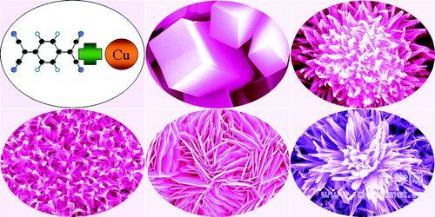
Figure 1. Describe the pictures

Refference
- I. S. Doe, J. Smith, P. Roe. J. Am. Chem. Soc. 1968, 90, 8234.

Title & Name (Chinese Name, if any)

Photo

Institution
Address
Tel:
Email:

Biography

